**Cave Profile Backend Details**

**1. Cave Name:** Since cave name is written in a downloaded font this field should have an upload image option to upload the name in the required font.

**2. Cave type:** Blank Field to be filled.

Image below shows cave name and cave type.

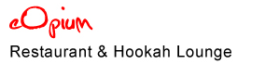

**3. Cover Picture of Cave:** Upload image. The image must be automatically reduced to fit the size. Details of Cave Rating given under “Bar below cover picture”

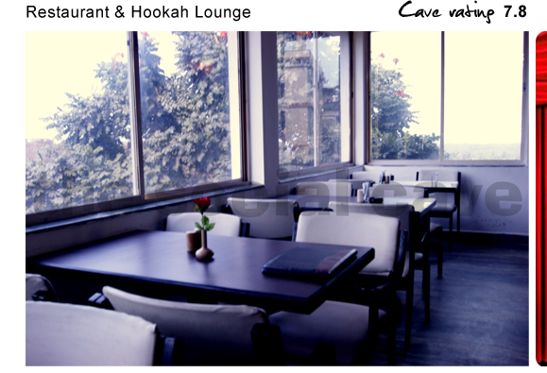

**4. Side Bar:**

The backend of a page should ask what side bar items we want to add for a particular cave.

Options to be made available for the sidebar (In order of preference)

-> Reviews

-> Photos

-> Facilities

-> Menu

-> Map

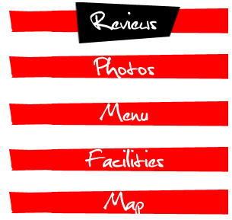

**Under Reviews:** Upto max 5 reviews appear on the first page. On clicking “**read** **more reviews**”, others are loaded on the same page below the existing ones. On the backend we must be allowed to mention the name of the person who has written the review with as option to link it with his **cave profile.**

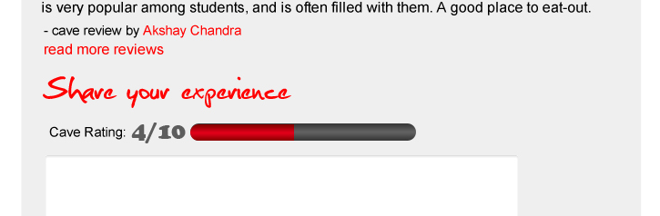

**Under Photos:** Option to upload photos of the cave.

Users are allowed to upload photos as well.

Again each photo should provide us a backend text field for the name of the photographer and a link to his **cave profile**.

**Under Menu:** Option to upload menus

**Under Facilities**:

Read “**Tags**” below for the list of facilities. If any facilities are selected it should get added on to the page automatically along with its picture.

**Under Map:** Should be linked with Google maps. Also a text field to enter the address and phone number. The address and phone number option must not appear if we do not select them in the back end.

**Tags:**

Each cave profile backend should have a variety of tags to choose from so that we know how it will appear on search results. There must be an entire list of check boxes with the following options for each page.

**Tags for search results from main page:**

Family, Friends, The Special One, Cool By MyselfI’m Broke, A Little Maybe, Money No ProblemBon Appetit, Connect with Nature, Just for Fun, Nightlife

**Under Bon Appetit:** Bakery, Café, Fast Food, Dine-In Restaurants**Under Connect With Nature:** Greenery, Worship Place, Water Body**Under Just For Fun:** Gaming Zone, Movie Theatre, Pool & Snooker, Sports**Under Nightlife:** Discotheque, Bar

**Facilities Available:** Air Conditioner, Bar, Buffet, Cards Accepted, Dance Floor, Dine In, Home Delivery, Music, Outdoor Seating, Pure Vegetarian, Smoking Allowed, Snacks Available, WiFi

A page can also me tagged as “**Featured Cave**” so that it appears at the top of search results.

**Other Features**

**1. Bar below Cover Picture:**



The visited button can be clicked when the user is logged in. This increases the visited count by 1. Also show a visitor the date of his last visit. On clicking on visited button a small rating bar appears that looks like:



Combing the rating of various users the “Cave Rating” is determined.

Also a user can add a place to his “**Favourites**”.

**2. User Ranks:**

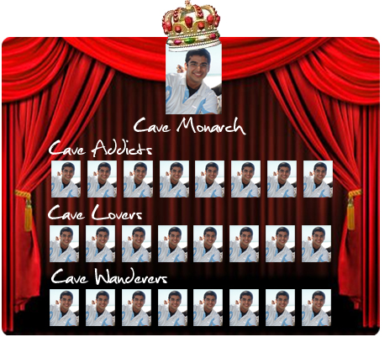

**Cave Wanderer:** Users become a Cave Wanderer as soon as they click on visited.

**Cave Lover:** On 5 visits.

**Cave Addict:** 5 visits + (either written a review or uploaded a photo of the cave)

**Cave Monarch:** if there are no cave addicts then user with max no of visits to cave. Else user with max visits from the Cave Addicts column.